Dataset Task:

Complete the code and obtain the resulting image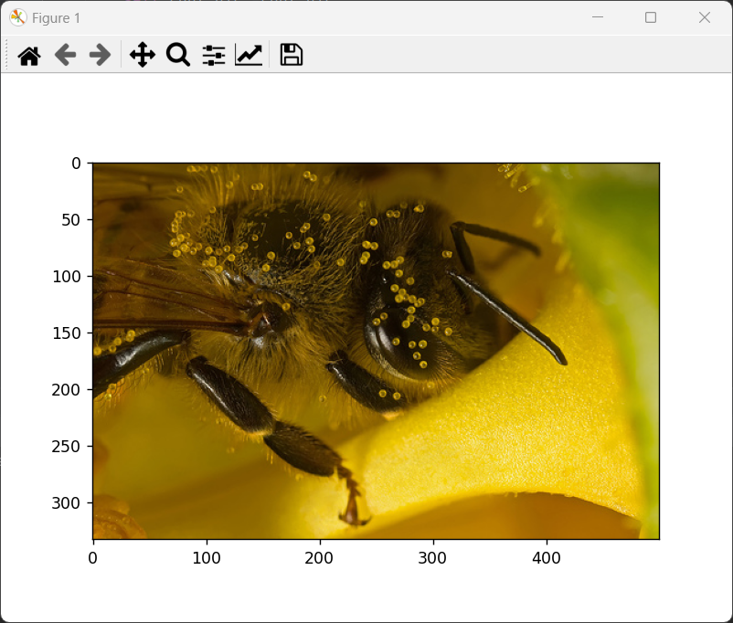

from torch.utils.data import Dataset

from PIL import Image

import matplotlib.pyplot as plt

import os

class MyData(Dataset):

def __init__(self,root_dir,label_dir):

def __getitem__(self, id):

def __len__(self):

root_dir =" "

bees_label_dir = ""

bees_dataset = MyData(root_dir,bees_label_dir)

img,label = bees_dataset[0]

plt.imshow(img)

plt.show()